**Desktop Virtualization: Installing a Virtual Machine**

**virtual machine using Oracle VM VirtualBox**

Go to virutalbox.org and download latest virtual box 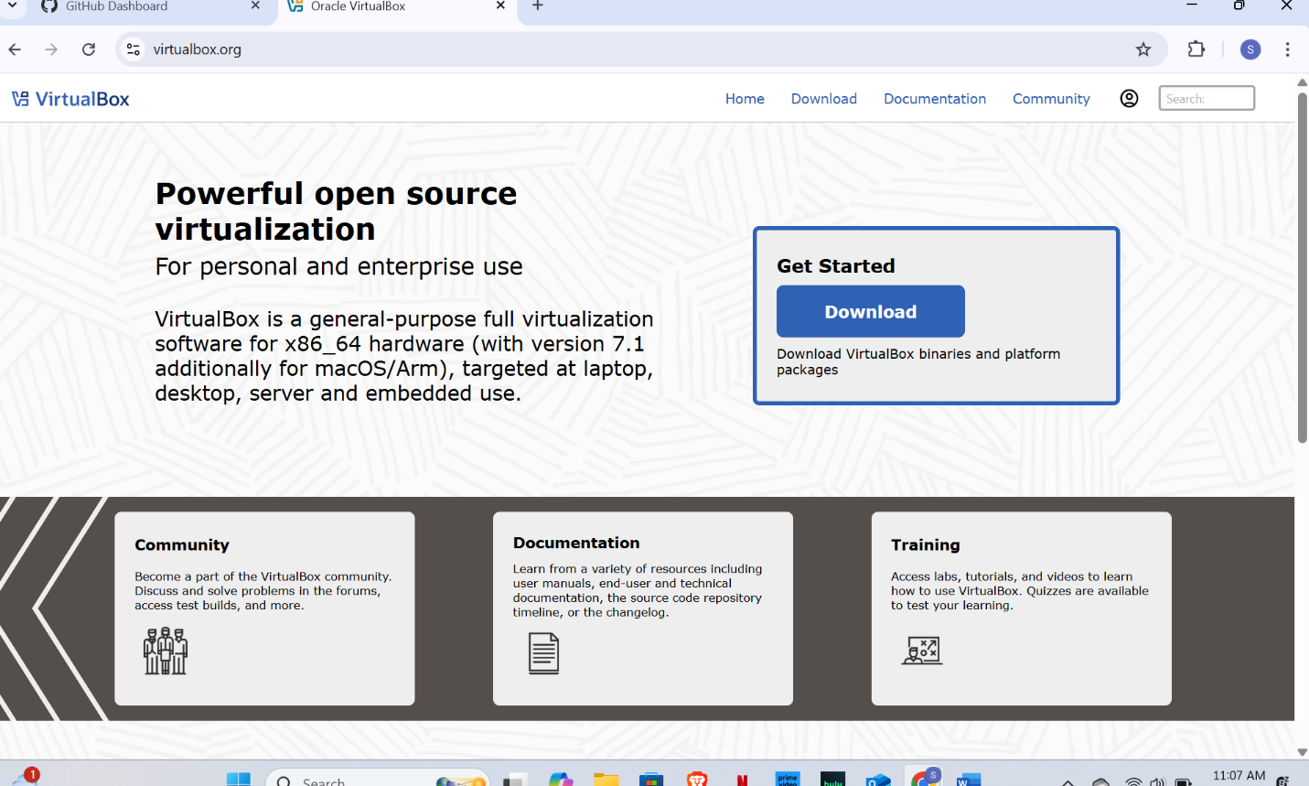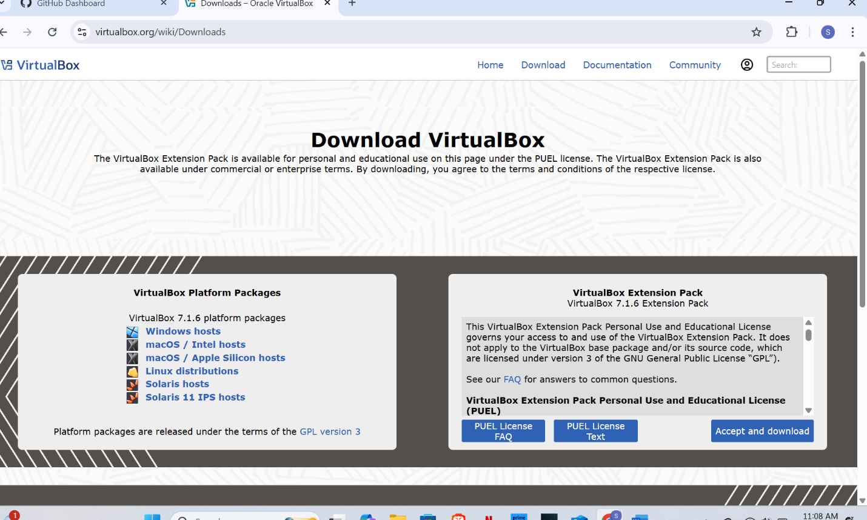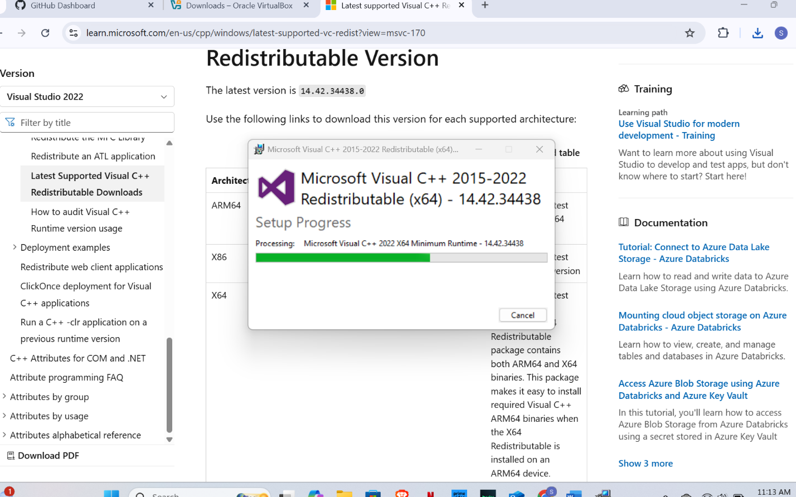

Install Microsoft Visual C++ Redistributable driver to install virtual box

VirtualBox is developed in C++ and **depends on these runtime components** to function correctly. Without them, certain core functions—such as loading kernel modules, rendering the UI, or running virtual machines—may fail or produce errors like:

* SUPR3HardenedWinRespawn
* “Kernel driver not installed”
* Unexpected crashes when launching the VM

**📌 Key Points:**

* It provides required **DLLs and runtime components** like MSVCP140.dll, VCRUNTIME140.dll, etc.
* These are needed for **VirtualBox services and UI** to work smoothly on Windows.
* The installer ensures that your system has the correct version of the C++ runtime for compatibility.

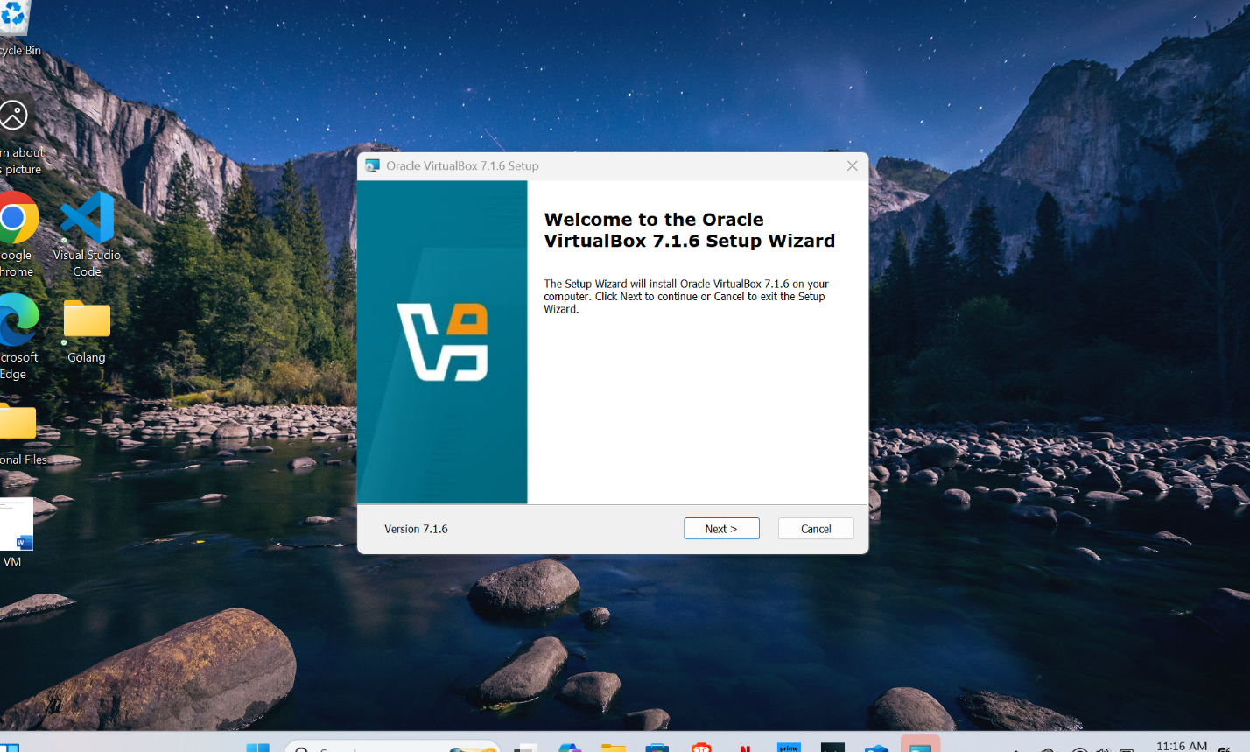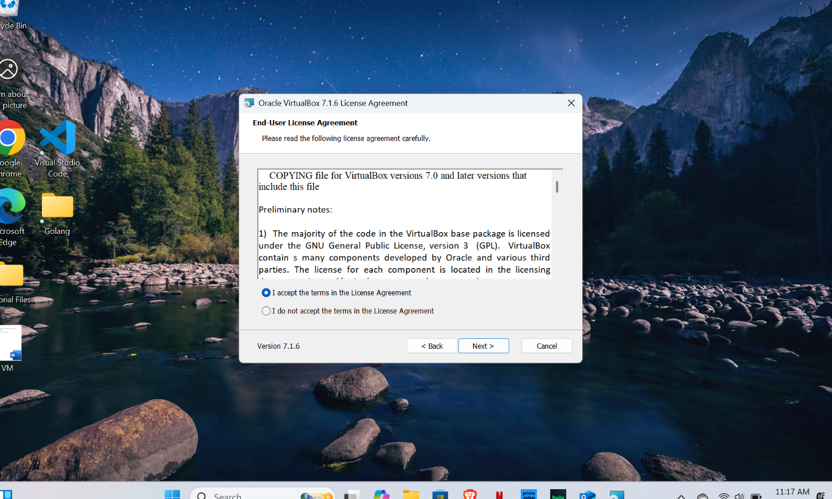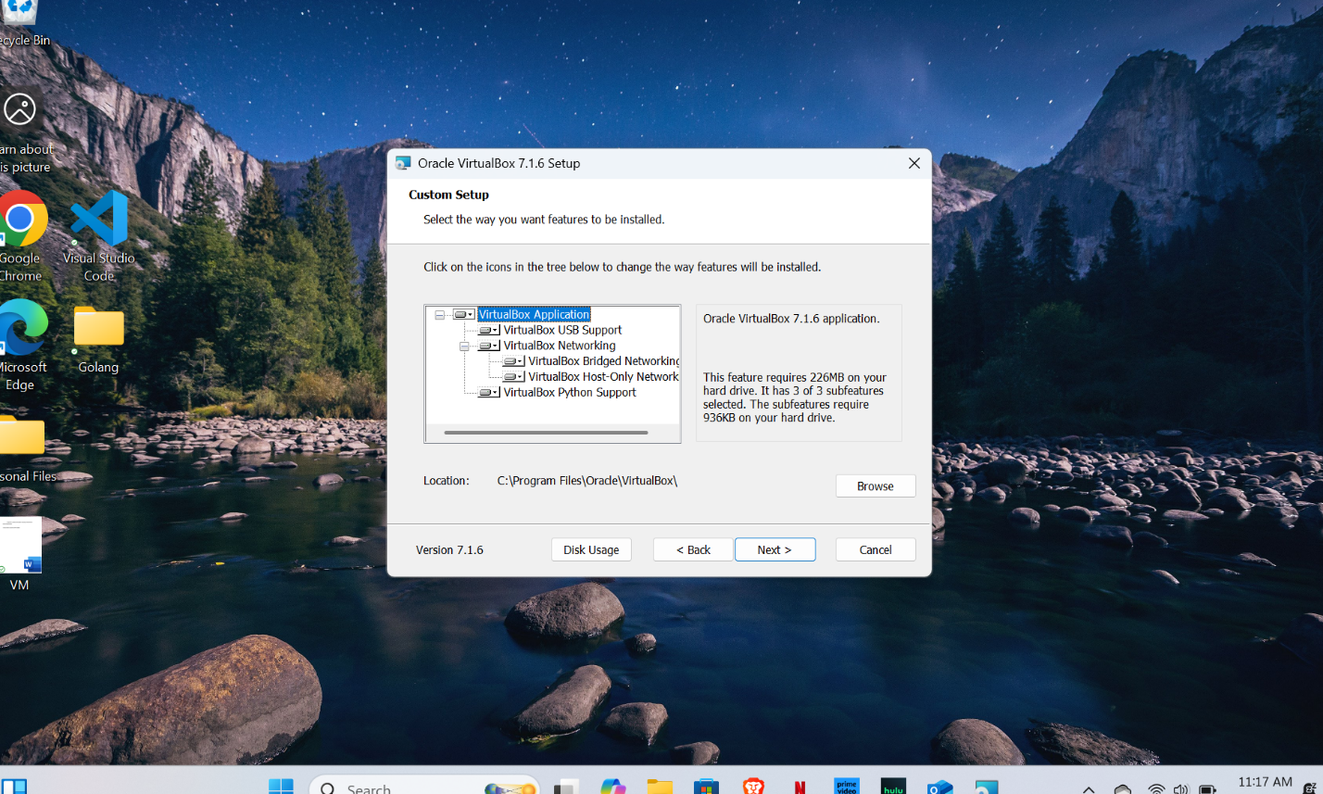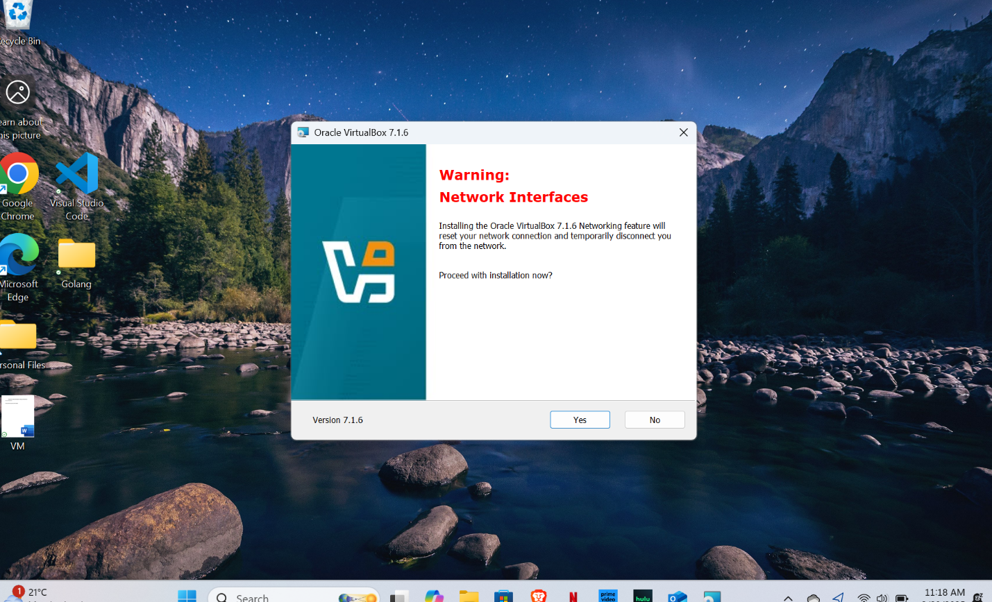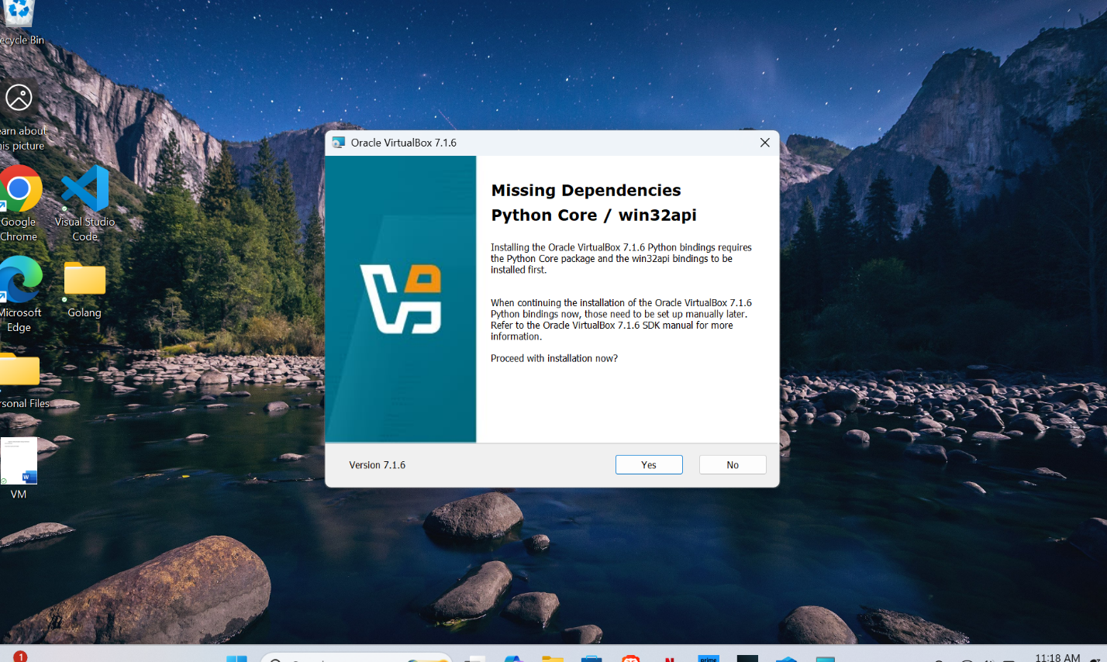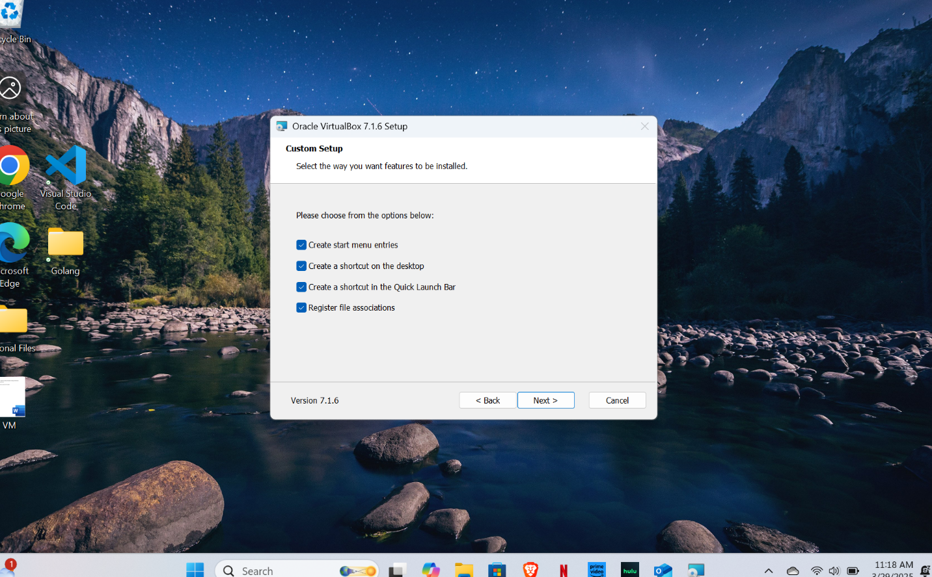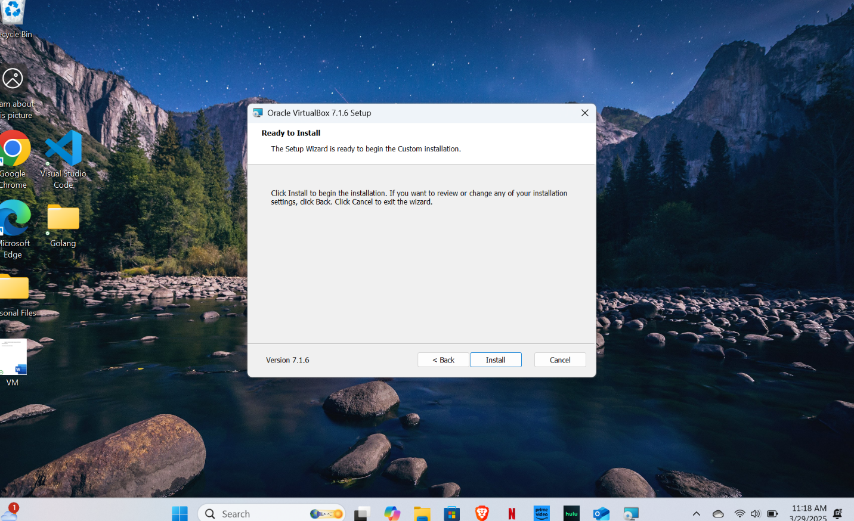

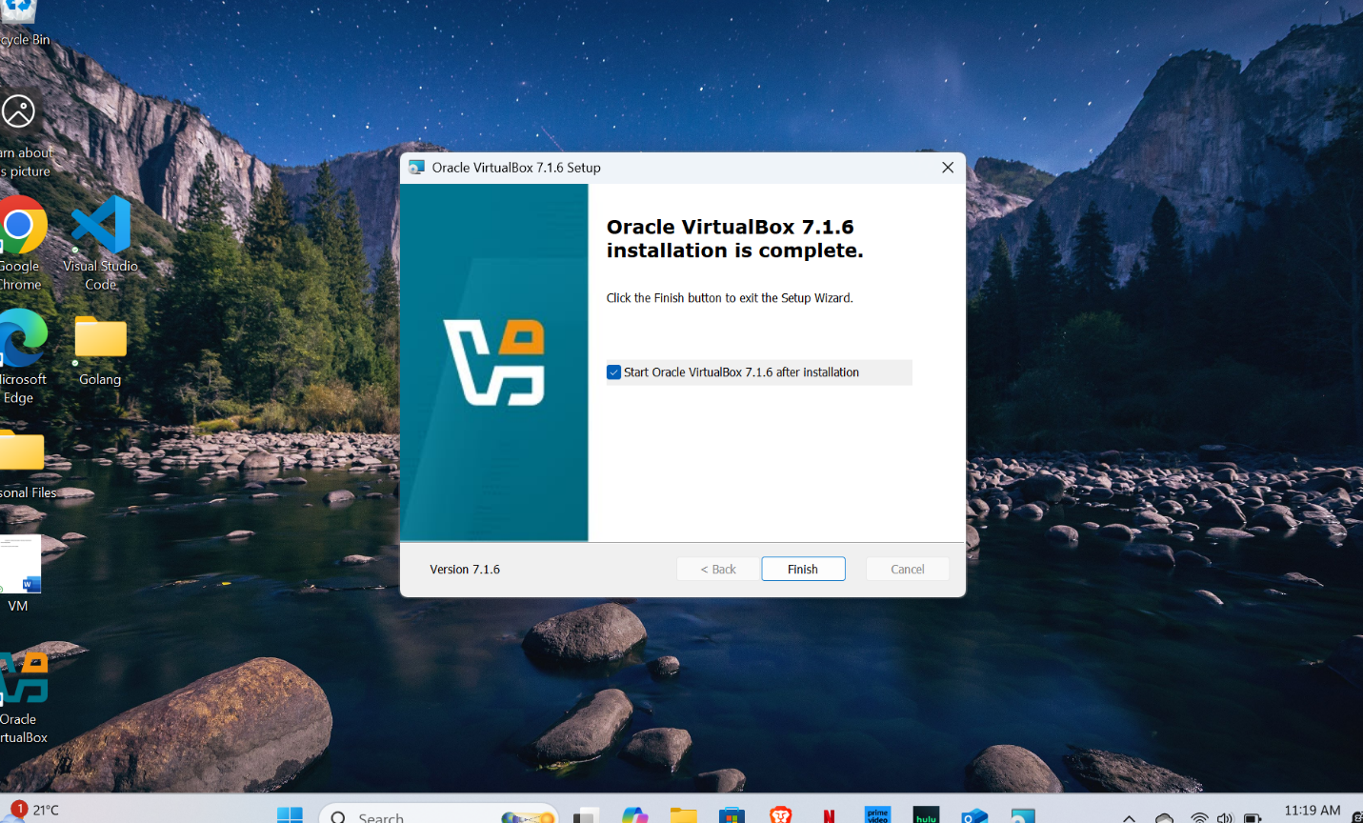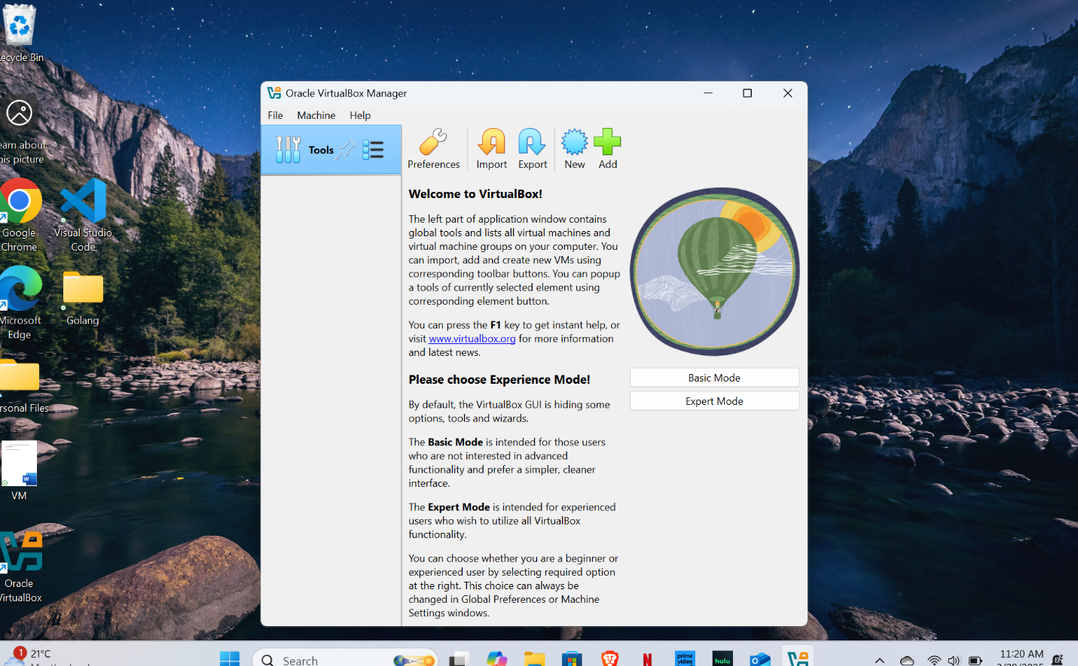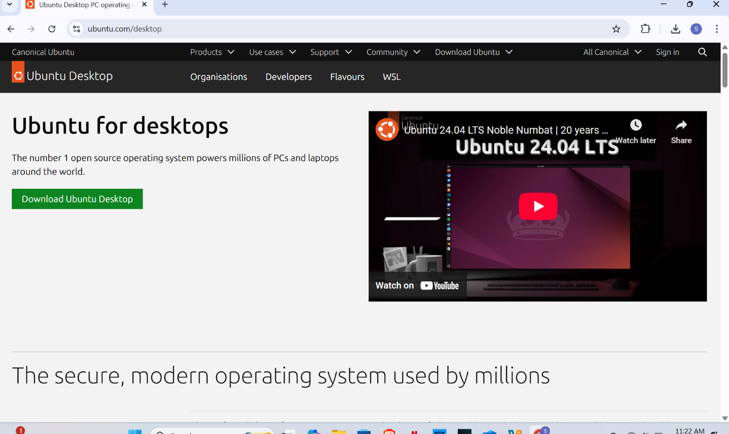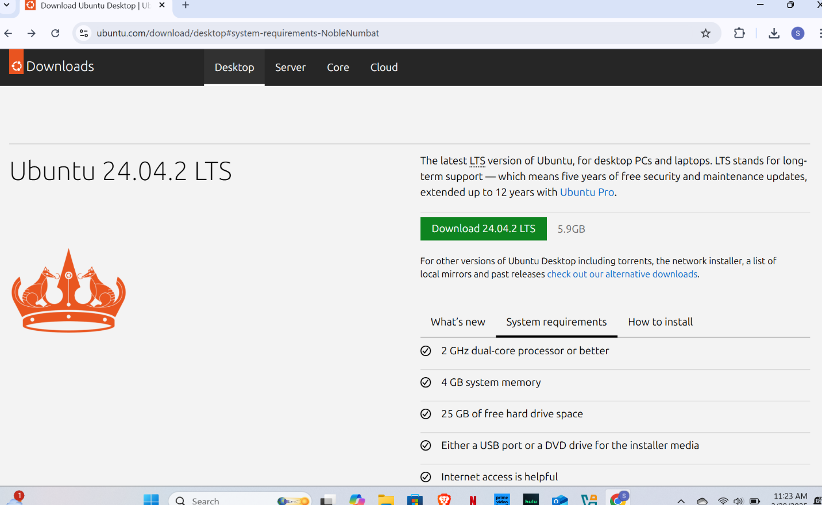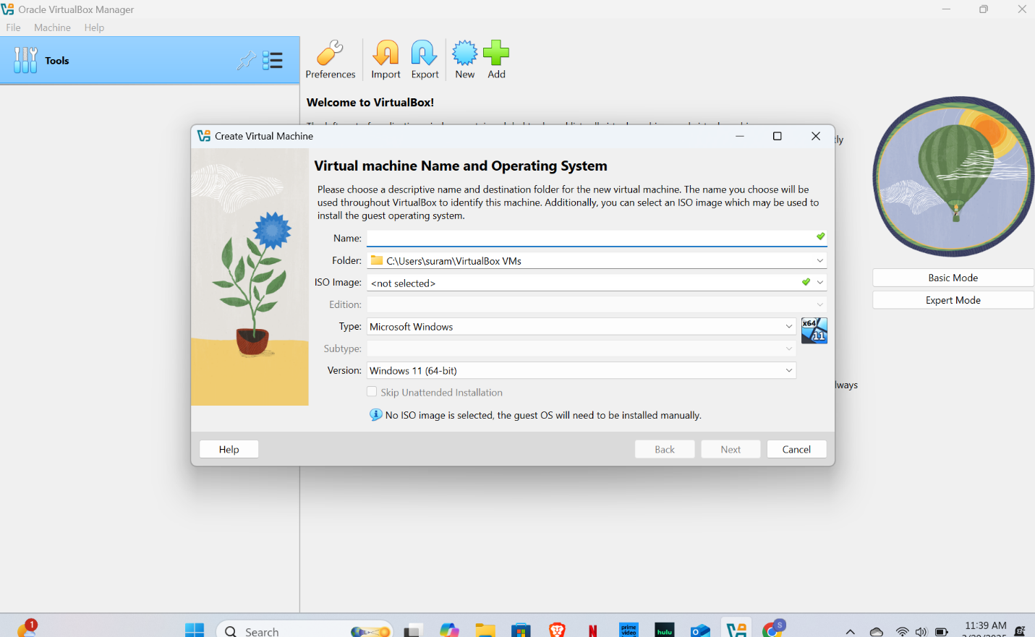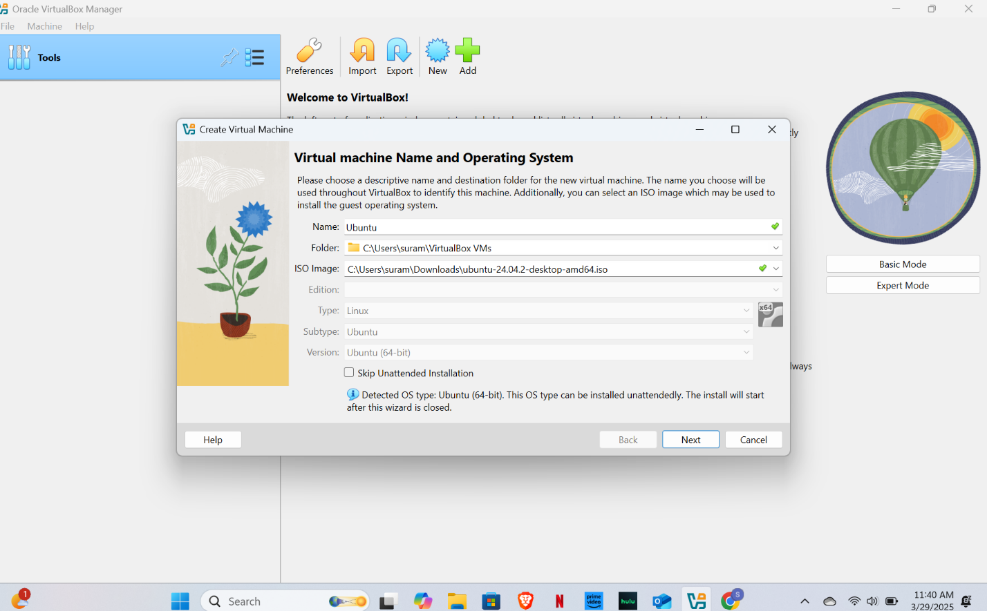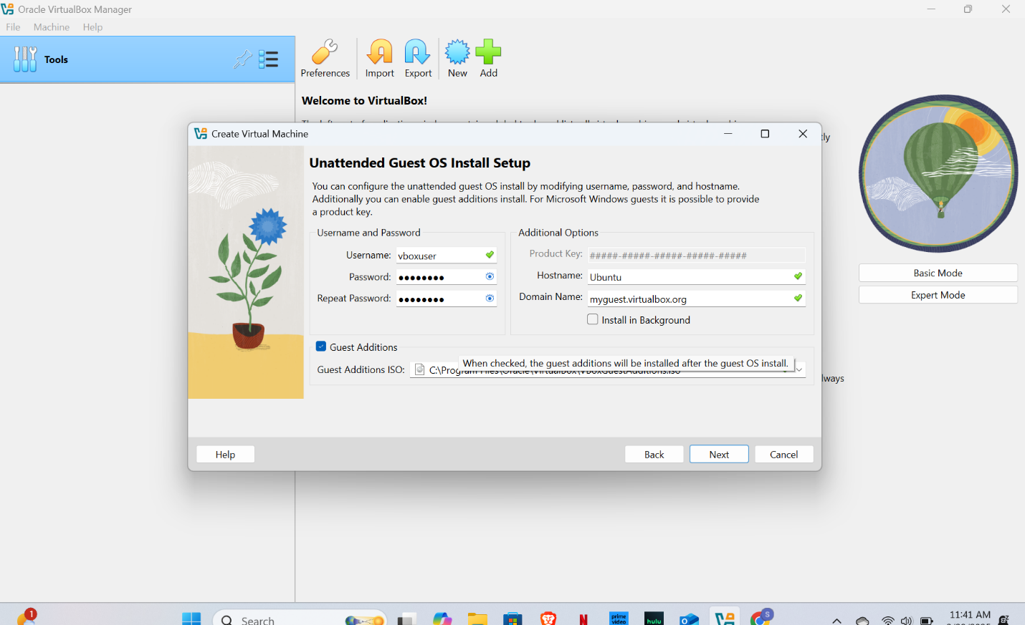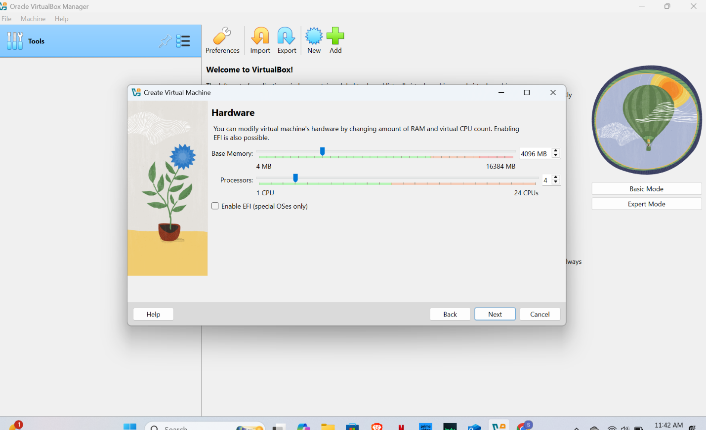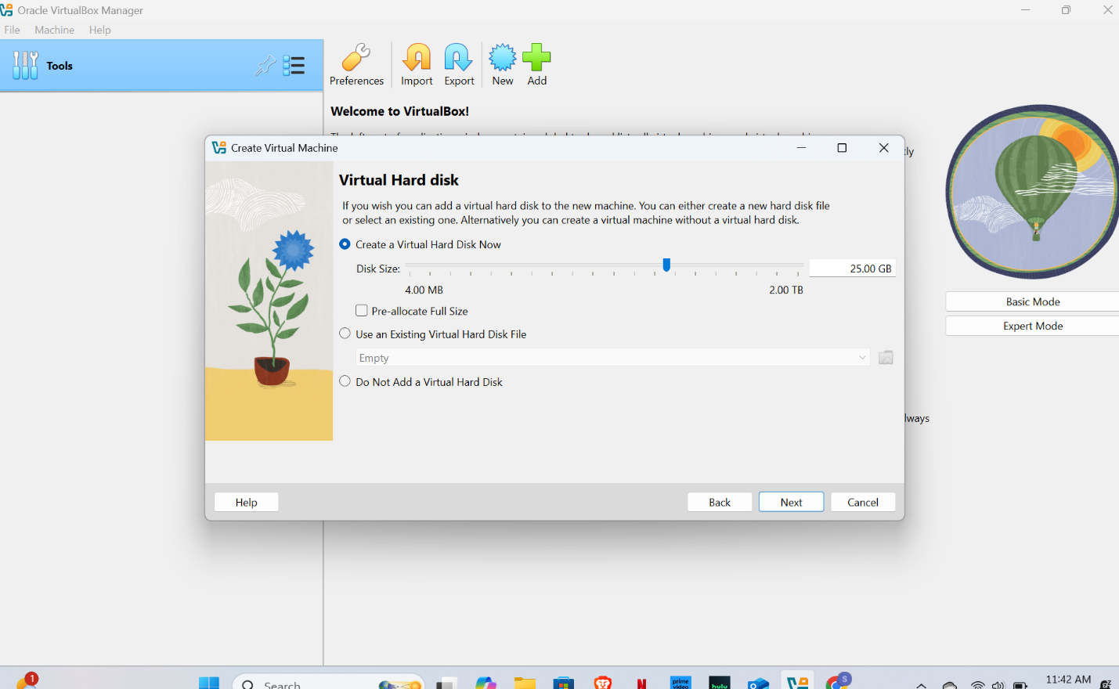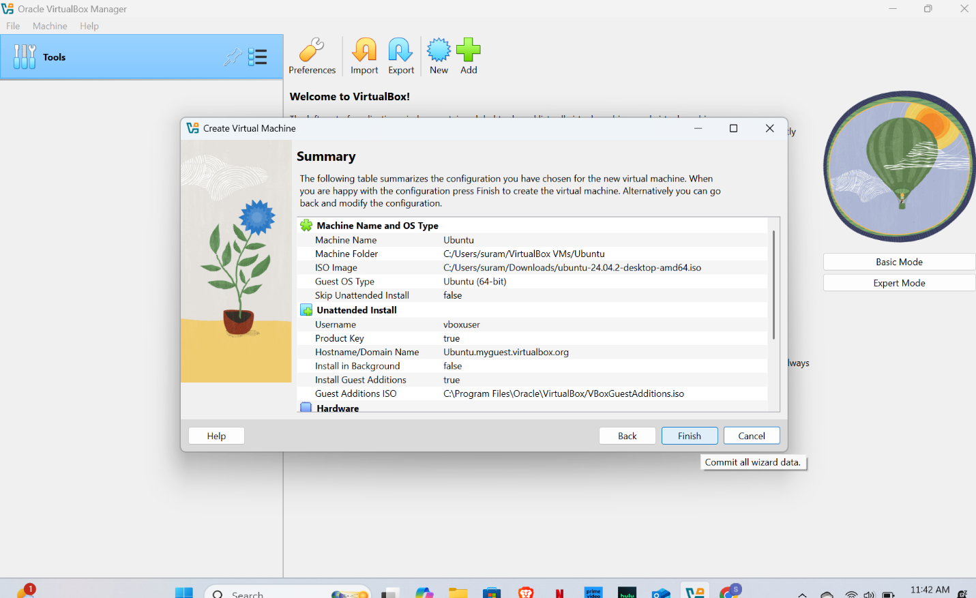

I used Oracle VM VirtualBox on my Windows system. However, during the first attempt, I encountered an error called **'SUPR3HardenedWinRespawn'**. This error usually happens when VirtualBox's kernel drivers fail to load properly, often due to permission issues or interference from antivirus software.

To overcome this error, I followed these steps:

1. **Uninstalled VirtualBox completely** and removed leftover files.
2. **Disabled my antivirus temporarily**, as it can block driver installations.
3. **Reinstalled VirtualBox as an administrator**, ensuring all features like USB and networking drivers were selected.
4. **Ran VirtualBox with admin privileges** and confirmed that the kernel modules were installed successfully.

After taking these steps, the error was resolved, and I was able to launch the virtual machine and install Ubuntu successfully.

